**Namatjira, Albert (Elea) (1902-1959)**

Albert Namatjira was the leading artist of the modern Aboriginal watercolour art movement at the Hermannsburg (Ntaria) Lutheran mission in Central Australia. He was the first Aborigine to be recognised as a professional artist, to make a good living from his art and gain national acclaim. The turning point in his life occurred in 1934, when two visiting landscape artists, Rex Battarbee and John Gardiner, exhibited paintings of the local scenery at the mission. Already a talented craftsman with a reputation on the mission for his artifacts and poker-worked designs, Namatjira was inspired by the exhibition to learn to paint his totemic landscape in the MacDonnell Ranges of Central Australia in the same modern landscape style. Namatjira’s paintings had a huge impact on the Western Arrernte, on other Aboriginal artists and on the wider Australian public. In depicting local ancestral sites in the pictorial language of Biblical illustrations, Namatjira’s paintings are a visual parallel to the Arrernte Bible, effectively translating their ancestral histories into a modern idiom. To this day the Western Arrernte consider Namatjira’s style as their own, as if it embodies their collective identity and history of the place. His success is considered a milestone in Australian art and the beginning of the modern Aboriginal art movement.

A Western Arrernte man of the Knguareaskin, Namatjira was born Elea (carpet snake) at the mission. There, in 1905, he was baptized with the name Albert. Having rights to his father’s totem – namatjira, the flying ant – he claimed this name in 1938 for his first solo exhibition, where he began signing his paintings Albert Namatjira. Two years earlier he had volunteered to be Battarbee’s guide and cameleer on a painting expedition in return for painting lessons. Battarbee always maintained that he didn’t teach Namatjira much at all, and that Namatjira’s natural talent enabled him to quickly master watercolour techniques. It was Namatjira, said Battarbee, who taught him how to see the Central Australian landscape.

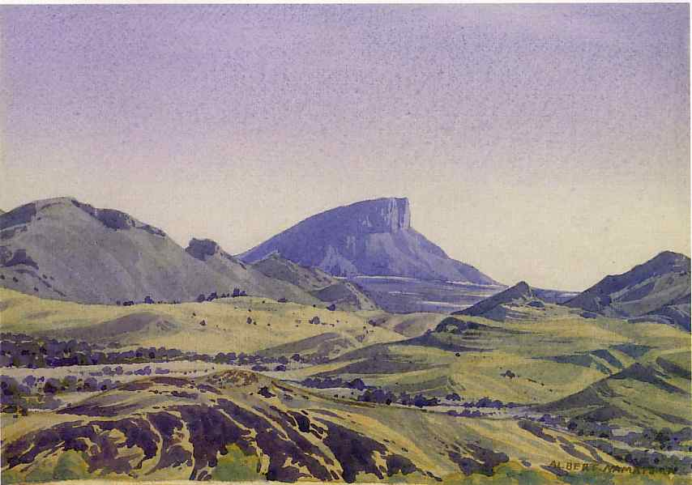

Albert Namitjira, *Mount Wedge from MacDonnell Ranges*, 1945, watercolour over pencil on paper, 26.3 x 19.4 cm, National Gallery of Victoria, Melbourne, Gift of Miss Helen Carneigie.

While Namatjira was familiar with Western pictorial conventions due to his education on the mission, Battarbee introduced Namatjira to the pictorial ideas of Western landscape painting tradition, from which Namatjira developed a distinctive style that captured the imagination of the Australian public. Battarbee and Namatjira remained life-long friends and painting partners, and together they nurtured a school of artists at the mission that thrives to this day.

Namatjira’s example also inspired other Aboriginal artists in remote and urban centres to be professional artists. As well, Namatjira’s art touched a nerve in the wider Australian public. By 1950 he was Australia’s most popular artist. His landscapes fetched high prices, all manner of dignitaries, from royalty to city mayors, honoured him, autograph seekers mobbed him and he was front-page news. However, few in the art world took his art seriously. His paintings were not included in any of the major exhibitions of Australian art at the time, and entered few public collections. Not until the advent of Aboriginal contemporary art in the late 1980s and 90s did the art world fully recognise his achievement.

**References and further reading**

French, A. (2002) *Seeing the Centre: The Art of Albert Namatjira 1902-1959*, Canberra: National Gallery of Australia

Hardy, J., Megaw, J. V. S., and Megaw, R. eds (1992)*The heritage of Namatjira: The watercolourists of Central Australia,* Port Melbourne: William Heinemann Australia.